ISO/IEC JTC 1/SC 29/WG 7 N223

ISO/IEC JTC 1/SC 29/WG 7
MPEG 3D Graphics Coding
Convenorship: AFNOR (France)

Document type: Output Document

Title: Subjective verification test report for V-PCC

Status: Approved

Date of document: 2021-11-15

Source: ISO/IEC JTC 1/SC 29/WG 7

Expected action: Approved

Action due date: None

No. of pages: 18 (with cover page)

Email of Convenor: marius.preda @ imt . fr

Committee URL: https://isotc.iso.org/livelink/livelink/open/jtc1sc29wg7

INTERNATIONAL ORGANIZATION FOR STANDARDIZATION
ORGANISATION INTERNATIONALE DE NORMALISATION
ISO/IEC JTC 1/SC 29/WG 7 MPEG 3D Graphics Coding

ISO/IEC JTC 1/SC 29/WG 7 N223
October 2021, Virtual

Title | Subjective verification test report for V-PCC
Source | WG 7, MPEG 3D Graphics Coding
Status | Draft
Serial Number | MDS20992

Abstract
Technical work on the 1st edition of the V3C/V-PCC standard has been accomplished in MPEG and ISO published the standard as ISO/IEC 23090-5:2021 [3] [4] [5] [6] [19] .
This report describes the results of the V-PCC subjective verification test, demonstrating the performance of the new standard. It summarizes information from the V-PCC Subjective Verification Test Plan provided by WG7 [21] and the V-PCC Verification Test Report provided by AG5 [23]. Both documents are non-public and therefore relevant parts of these documents are reproduced in this test report.

Introduction
This report describes the detailed logistics and the results of the V-PCC subjective verification test. The test was focused on well distinguishable V-PCC profiles and targets lossy compression that is appropriate for consumer applications. Time varying dynamic point clouds have been selected as test material, while a known state-of-the-art point cloud codec was selected as the anchor that fits the test conditions.
The test was conducted in line with the subjective verification test guidelines documented in AG5 N00030 [13].
This report is publicly available and notably intended to be shared with application standards organizations interested in V-PCC.

Verification test logistics
The following verification labs performed the subjective test:
- VABTech London UK
- GBTech Rome Italy
The tests were conducted using the DSIS test method [1] with the impairment scale described in Annex A.

Codecs under test

V-PCC
The V3C/V-PCC specification [19] specifies a number of V-PCC profiles where each profile specifies a subset of algorithmic features and limits, which indicate what shall be supported by all decoders conforming to that profile. A V-PCC profile consists of three components. A Codec-group component, a Toolset component, and a Reconstruction component. The Codec-group component describes the underlying 2D video codec and their profile (e.g. HEVC Main10, etc.), the Toolset component describes V-PCC specific tools (e.g. EOM or PLR, etc.), and the Reconstruction component describes the reconstruction (e.g. Rec2) process that is recommended to the decoder to achieve a certain level of reconstruction quality when decoding a particular bitstream. Currently, two Toolset component subprofiles, the V-PCC Basic and Extended Toolset subprofiles, have been defined for the compression of point cloud data using V-PCC. Conformance to the Reconstruction component is optional and decoders may select to follow a different reconstruction process than the one indicated in a bitstream.
Annex A of [19] describes the profiles in detail, while Annex H.15.4 of [19] describes the V-PCC Basic and V-PCC Extended Toolset component subprofiles. Annexes H.10 and H.11 of [19] describe the Reconstruction (e.g. Rec1, Rec2, etc.) component subprofiles.
In this test, subjective verification testing was performed for the following V-PCC profiles:
- HEVC Main10 V-PCC Basic Rec2
- HEVC Main10 V-PCC Extended Rec2
- VVC Main10 V-PCC Extended Rec2
Note that HEVC Main10 is a widely implemented video coding profile of the HEVC Video coding standard [25] on TV sets and mobile phones and VVC Main10 is the corresponding profile of the VVC standard [24], a next generation video coding standard recently developed by JVET, that promises further coding gains for image/video data.
Note that “Rec2” reconstruction was used in all selected profiles in this test. The produced bitstreams could be reconstructed with different methodologies that may provide different quality-implementation trade-offs. However, these trade-offs were not evaluated in this test.
The suitability of the selected profiles was verified in an expert viewing dry-run [11].

Anchor codec
CWI-PCL-Codec was selected as the anchor codec [9]. The performance of the anchor has been studied in [12].

Test conditions and test material

Test conditions
The point cloud test material was evaluated under the following conditions:

Condition | Test condition | TMC2
 |  | AI | RA
C2 | Near-lossless | Lossy Geometry – Lossy Attributes |  | ✓
Table 1 List of test conditions
Note: “lossy” and “near-lossless” geometry/colour/reflectance encoding are defined in the “Requirements for Point Cloud Compression” output document [6]. For clarity, near-lossless implies a bounded error rather than the magnitude of the error (i.e. near-lossless does not necessarily imply nearly lossless).
Note: Test condition CW (Lossless Geometry – Lossless Attributes) was not subjectively tested.

Selection of test material and rate points
Generally, it is discouraged to select test material for verification tests that has already been used for the development of a coding standard. Therefore, recently received test material from Volucap, XD Productions, and Volugrams has been selected for this test. The following 10-bit sequences were selected for formal subjective verification tests:
- Volucap/Mitch
- Volucap/Thomas
- XD Productions/Football
- Volograms/Levi
The following 10-bit sequences were selected for the demonstration sessions:
- 8i/Longdress
- 8i/Loot
All test material can be downloaded in zip format from the folder: ftp://mpegcontent@mpegfs.int-evry.fr/MPEG-I/Part05-PointCloudCompression/V3C/VerificationTests/contents/10bits/
The test subject training included a demo trial on interactivity with point cloud content. Test subjects had the opportunity to understand the purpose of point cloud content by playing with the content.
The preparation of the test material is described in document [10].
Five rate points, R1 to R5, were used for each test sequence. Encoding was performed with Random Access (RA) applications in mind. The rate points were fixed using designed configuration files, which are described in the next chapter.

Generation of video sequences
The test used the reference encoder that is provided with the V-PCC standard. Note that the performance of the produced bitstreams is impacted by the design of the encoder, as well as by the design of the underlying video encoders, the bitrates selected for the geometry and texture layers, and other coding settings. Different encoders could result in different performance (better or worse) from what was achieved in this evaluation.

Encoding and decoding of V-PCC bitstreams
The V-PCC test model software can be downloaded from the MPEG PCC software repository: http://mpegx.int-evry.fr/software/MPEG/PCC/TM/mpeg-pcc-tmc2
Usage of the software is described in the readme file at the top level.
The following is an example of the encoding command line:
./mpeg-pcc-tmc2/bin/PccAppEncoder \
--config=./mpeg-pcc-tmc2/cfg/common/ctc-common.cfg \
--config=./contents/configurationFiles/${sequence}.cfg \
--configurationFolder=./mpeg-pcc-tmc2/cfg/ \
--uncompressedDataFolder=./contents/10bits/${sequence}/ \
--compressedStreamPath=./${sequence}.bit \
--geometryQP=$QPG \
--attributeQP=$QPA \
--occupancyPrecision=$OCM \
--resolution=1023 \
--nbThread=1 \
+ additional parameters

The parameters QPG, QPA, and OCM, correspond to the columns named as "QP Geo", "QP Attribute", and "Occupancy precision" in Table 2 and Table 3 .
${sequence}.cfg indicates a corresponding sequence configuration file.
Configuration files for the test material football_vox10, levi_vox10, longdress_vox10, loot_vox10, mitch_vox10 and thomas_vox10 can be found here: ftp://mpegcontent@mpegfs.int-evry.fr/MPEG-I/Part05-PointCloudCompression/V3C/VerificationTests/contents/configurationFiles/

The following subchapters describe the additional parameters for each profile.

Additional parameters for HEVC Main10 Basic Rec2 and Extended Rec2
The following additional parameters were needed for the HEVC Main10 Basic Rec2 encodings:
“
--config=./mpeg-pcc-tmc2/cfg/condition/ctc-random-access.cfg \
--profileToolsetIdc=0\
--profileReconstructionIdc=2\
--mapCountMinus1=1\
--pbfEnableFlag=1
“
The following additional parameters were needed for the HEVC Main10 Extended Rec2 encodings:
“
--config=./mpeg-pcc-tmc2/cfg/condition/ctc-random-access.cfg \
--profileToolsetIdc=1\
--profileReconstructionIdc=2\
--mapCountMinus1=0\
--pointLocalReconstruction=1\
--pbfEnableFlag=1\
--useEightOrientations=1\
--flagColorSmoothing=1\
--additionalProjectionPlaneMode=5
“

Additional parameters for VVC Main10 Extended Rec2
The following additional parameters were needed for the VVC Main10 Extended Rec2 encodings:
”
--config=./mpeg-pcc-tmc2/cfg/condition/vtm-random-access.cfg \
--profileCodecGroupIdc=3\
--profileToolsetIdc=1\
--profileReconstructionIdc=2\
--mapCountMinus1=0\
--pointLocalReconstruction=1\
--pbfEnableFlag=1\
--useEightOrientations=1\
--flagColorSmoothing=1\
--additionalProjectionPlaneMode=5
“
Configurations for the VVC reference software (VTMv13.0) can be found here: https://mpeg.expert/software/MPEG/PCC/TM/mpeg-pcc-tmc2/-/tree/master/cfg/vtm

Decoding of V-PCC bitstreams
The following is an example for the decoding command line:
./mpeg-pcc-tmc2/bin/PccAppDecoder \
--startFrameNumber=0 \
--compressedStreamPath=$BISTREAMS \
--reconstructedDataPath=decoded_04d.ply \
--inverseColorSpaceConversionConfig=./mpeg-pcc-tmc2/cfg/hdrconvert/yuv420toyuv444_16bit.cfg

Encoding and decoding using CWI-PCL-Codec
CWI-PCL-Codec was selected as the anchor codec for the V-PCC subjective verification tests. Information on codec configuration and draft results for the anchor have been collected in the anchor codec description [12].
The anchor software can be downloaded from the MPEG content FTP repository: https://mpegfs.int-evry.fr/mpegcontent/ws-mpegcontent/MPEG-I/Part05-PointCloudCompression/V3C/VerificationTests/Anchor/Software/
Users should follow the instructions provided on https://github.com/cwi-dis/cwi-pcl-codec when preparing and compiling the software for a particular environment. A patch file is provided for bug fixes under the same folder. Usage of the software is described in the readme document at the same level.
The following is an example for the encoding and decoding command line:
./evaluate_compression.exe \
-i ./input/path \
-o ./output/path \
-b $OCT \
-c 8 \
-d 1 \
-g 32 \
-j 85 \
-m 16 \
--intra_frame_quality_csv=./output_intra_quality_g8_c8_GOP32_JPEG85_M16.csv \
--predictive_quality_csv./output_ predictive_quality_g8_c8_GOP32_JPEG85_M16.csv \
--do_quality_computation=1

The parameters OCT correspond to the columns named as "octree_bits” in Table 5.

List of generated bitstreams
This section lists all generated bitstreams with their actual bitrate and the detailed configurations for Occupancy Precision, Geometry QP, and Attribute QP.

HEVC Main10 Basic Rec2
Sequences | Rate | Target Bitrate [kbps] | Actual Bitrate  [kbps] | Occupancy precision | QP  Geo | QP  Attribute | GeoBit  [kbps] | AttBit  [kbps] | OccBit  [kbps]
football | R01 | 2500 | 2642.95 | 4 | 28 | 37 | 905.08 | 1297.81 | 440.05
 | R02 | 5000 | 5315.88 | 4 | 21 | 31 | 1634.51 | 3241.31 | 440.05
 | R03 | 10000 | 10055.41 | 2 | 16 | 26 | 2694.46 | 6477.68 | 883.26
 | R04 | 15000 | 14451.85 | 2 | 13 | 23 | 3716.18 | 9852.39 | 883.26
 | R05 | 25000 | 25913.16 | 2 | 9 | 19 | 5925.90 | 19103.99 | 883.26
mitch | R01 | 2500 | 2646.25 | 4 | 26 | 35 | 1225.00 | 890.97 | 530.2608
 | R02 | 5000 | 5176.32 | 2 | 21 | 31 | 1953.25 | 2099.82 | 1123.24
 | R03 | 10000 | 9480.49 | 2 | 17 | 27 | 3032.57 | 5324.66 | 1123.24
 | R04 | 15000 | 15941.30 | 2 | 16 | 24 | 3395.19 | 11422.86 | 1123.24
 | R05 | 25000 | 26175.07 | 2 | 12 | 22 | 5392.86 | 19658.96 | 1123.24
thomas | R01 | 2500 | 2524.50 | 4 | 20 | 30 | 1194.36 | 1019.20 | 310.9224
 | R02 | 5000 | 5326.72 | 2 | 16 | 26 | 1955.49 | 2671.70 | 699.52
 | R03 | 10000 | 9332.19 | 2 | 13 | 23 | 2805.80 | 5826.86 | 699.52
 | R04 | 15000 | 14332.14 | 2 | 11 | 21 | 3638.64 | 9993.97 | 699.52
 | R05 | 25000 | 26231.19 | 2 | 9 | 18 | 4829.45 | 20702.20 | 699.52
levi | R01 | 2500 | 2671.40 | 4 | 24 | 34 | 1333.12 | 875,52 | 462,72
 | R02 | 5000 | 5265.99 | 2 | 18 | 28 | 2376,04 | 1924.26 | 965.66
 | R03 | 10000 | 10547.84 | 2 | 12 | 22 | 4601.54 | 4980.62 | 965.66
 | R04 | 15000 | 15928.62 | 4 | 9 | 18 | 6541.48 | 8924.38 | 462.72
 | R05 | 25000 | 26733.34 | 2 | 5 | 15 | 12880.58 | 12887.08 | 965.66
Table 2 HEVC Main10 Basic Rec2

HEVC Main10 Extended Rec2
Sequences | Rate | TargetBitrate  [kbps] | Bitrate  [kbps] | Occupancy precision | QPGeo | QP Attribute | GeoBit  [kbps] | AttBit  [kbps] | OccBit  [kbps]
football | R01 | 2500 | 2581.19 | 4 | 29 | 39 | 971.13 | 1130.84 | 479.21
 | R02 | 5000 | 5202.12 | 4 | 22 | 32 | 1614.78 | 3108.12 | 479.21
 | R03 | 10000 | 9963.33 | 2 | 17 | 27 | 2766.62 | 6236.40 | 960.29
 | R04 | 15000 | 15962.23 | 2 | 14 | 23 | 3523.68 | 11478.25 | 960.29
 | R05 | 25000 | 25527.68 | 2 | 10 | 20 | 5513.56 | 19053.82 | 960.29
mitch | R01 | 2500 | 2592.08 | 4 | 27 | 37 | 1283.86 | 723.17 | 585.03
 | R02 | 5000 | 5273.80 | 4 | 21 | 31 | 2199.79 | 2488.96 | 585.03
 | R03 | 10000 | 9351.42 | 2 | 18 | 28 | 3152.74 | 4982.31 | 1216.36
 | R04 | 15000 | 15987.84 | 2 | 17 | 25 | 3507.44 | 11264.03 | 1216.36
 | R05 | 25000 | 24746.24 | 2 | 13 | 23 | 5148.00 | 18381.87 | 1216.36
thomas | R01 | 2500 | 2647.45 | 4 | 22 | 31 | 1236.23 | 1057.74 | 353.47
 | R02 | 5000 | 4903.04 | 2 | 18 | 28 | 2100.78 | 2010.91 | 791.33
 | R03 | 10000 | 9879.20 | 2 | 14 | 24 | 2986.96 | 6100.90 | 791.33
 | R04 | 15000 | 15717.89 | 2 | 12 | 22 | 3845.83 | 11080.72 | 791.33
 | R05 | 25000 | 23302.60 | 2 | 10 | 20 | 5031.25 | 17480.01 | 791.33
levi | R01 | 2500 | 2654.32 | 4 | 26 | 35 | 1264.86 | 873.40 | 516.02
 | R02 | 5000 | 5271.13 | 4 | 19 | 28 | 2398.50 | 2356.58 | 516.02
 | R03 | 10000 | 10485.55 | 2 | 13 | 23 | 4310.48 | 5104.04 | 1071.02
 | R04 | 15000 | 15132.08 | 2 | 10 | 20 | 6104.22 | 7956.82 | 1071.02
 | R05 | 25000 | 25575.12 | 2 | 6 | 16 | 11154.70 | 13349.38 | 1071.02
Table 3 HEVC Main10 Extended Rec2

VVC Main10 Extended Rec2
Sequences | Rate | TargetBitrate  [kbps] | Bitrate  [kbps] | Occupancy precision | QPGeo | QP Attribute | GeoBit  [kbps] | AttBit  [kbps] | OccBit  [kbps]
football | R01 | 2500 | 2522.78 | 2 | 28 | 38 | 827.59 | 935.66 | 759.51
 | R02 | 5000 | 4967.21 | 4 | 24 | 30 | 1188.50 | 3386.73 | 391.97
 | R03 | 10000 | 10593.92 | 2 | 16 | 25 | 2520.75 | 7313.64 | 759.51
 | R04 | 15000 | 15536.44 | 2 | 16 | 22 | 2520.75 | 12256.17 | 759.51
 | R05 | 25000 | 25921.22 | 2 | 20 | 18 | 1730.76 | 23430.93 | 759.51
mitch | R01 | 2500 | 2546.81 | 2 | 32 | 34 | 648.81 | 939.08 | 958.90
 | R02 | 5000 | 4789.99 | 2 | 24 | 30 | 1351.82 | 2479.25 | 958.90
 | R03 | 10000 | 10468.11 | 2 | 20 | 26 | 2052.68 | 7456.51 | 958.90
 | R04 | 15000 | 15804.38 | 2 | 12 | 25 | 4668.94 | 10176.53 | 958.90
 | R05 | 25000 | 26678.94 | 2 | 16 | 22 | 3084.81 | 22635.21 | 958.90
thomas | R01 | 2500 | 2333.53 | 2 | 20 | 34 | 1272.37 | 442.75 | 618.39
 | R02 | 5000 | 4994.71 | 2 | 20 | 26 | 1272.37 | 3103.93 | 618.39
 | R03 | 10000 | 9541.75 | 2 | 17 | 23 | 1784.19 | 7139.15 | 618.39
 | R04 | 15000 | 14182.83 | 2 | 11 | 22 | 3474.80 | 10089.62 | 618.39
 | R05 | 25000 | 26425.19 | 2 | 20 | 18 | 1272.37 | 24534.42 | 618.39
levi | R01 | 2500 | 2566.82 | 4 | 20 | 42 | 1856.46 | 288.82 | 421.52
 | R02 | 5000 | 5321.76 | 2 | 20 | 26 | 1842.24 | 2631.98 | 847.52
 | R03 | 10000 | 10635.18 | 2 | 24 | 18 | 1235.60 | 8552.02 | 847.52
 | R04 | 15000 | 15450.99 | 2 | 8 | 19 | 6739.70 | 7863.74 | 847.52
 | R05 | 25000 | 26557.96 | 2 | 24 | 10 | 1235.60 | 24474.80 | 847.52
Table 4 VVC Main10 Extended Rec2

CWI-PCL Anchor

Sequences | Rate | Bitrate [kbps] | octree_bits
football | R01 | 11650.10 | 8
 | R02 | 35725.43 | 9
 | R03 | 81953.97 | 10
 | R04 | 147739.92 | 11
 | R05 | 221096.90 | 12
mitch | R01 | 6900.25 | 8
 | R02 | 21524.25 | 9
 | R03 | 69968.66 | 10
 | R04 | 159565.44 | 11
 | R05 | 308379.11 | 12
thomas | R01 | 10675.95 | 8
 | R02 | 29225.23 | 9
 | R03 | 67228.11 | 10
 | R04 | 171967.45 | 11
 | R05 | 338192.96 | 12
levi | R01 | 7002.48 | 8
 | R02 | 19706.28 | 9
 | R03 | 53049.71 | 10
 | R04 | 122895.71 | 11
 | R05 | 221255.28 | 12
Table 5 CWI-PCL Anchor

Rendering of 2D videos for subjective evaluation
The selected encoded and decoded test sequences were rendered using the point cloud renderer selected by MPEG [2]. This renderer does not include any additional post-processing for improving the image quality. The rendering view-point/camera path for the four formal test sequences was created in collaboration between AG5 and WG7. The results in a form of txt files can be found here: ftp://mpegcontent@mpegfs.int-evry.fr/MPEG-I/Part05-PointCloudCompression/V3C/VerificationTests/videos_new_camera_path_20211004/
To avoid interference between the background and the test material, a neutral background with the color (0.6/0.6/0.6) was selected. A floor with the color (0.5/0.5/0.5) makes the rendered scene more realistic by preventing interference with the test material.
The video sequences were generated with the following video parameters:
- Video resolution: progressive uncompressed full-range HD format (1920x1080).
Note that upsampling by the TV set should be avoided
- Frame rate: The frame rate was aligned with the frame rate in the test data set
- Color space: ITU-R BT.709
- Sub-sampling: 4:2:0 YUV 10 bits
The renderer command lines for generating the videos can be found in the following file: ftp://mpegcontent@mpegfs.int-evry.fr/MPEG-I/Part05-PointCloudCompression/V3C/VerificationTests/contents/cameraPath/command_renderer.txt
The output of this camera path was stored as high-quality video sequences of a length as close as possible to 10s.
The resulting videos that were subjectively evaluated can be found here: ftp://mpegcontent@mpegfs.int-evry.fr/MPEG-I/Part05-PointCloudCompression/V3C/VerificationTests/yuv_videos_new_camera_path_20211004
These video sequences were viewed and evaluated by naïve viewers using the DSIS (Double Stimulus Impairment Scale) [1] method, which is described in more detail in Annex A.
Complementary information can be found in [17] and [22].

Crosschecks and dry-run
All HEVC Codec profile V-PCC bitstreams and the anchor bitstreams were fully cross-checked. VVC Codec profile V-PCC bitstreams were randomly partially cross-checked. Generation of videos has been cross-checked by verifying script parameters and by randomly checking the resulting video quality. The respective cross-checks are documented in [16][17][18].
Suitability of produced videos was checked in an expert viewing dry-run [14][15].

Test results
In this chapter the results of the formal subjective assessment of the 2D video sequences are reported.

Tables of the results

Sequence | Ratepoint | Bitrate [kbps] | MOS | MOS-CI
football | R1 | 11650,1 | 0,7 | 0,35
football | R2 | 35725,43 | 1,8 | 0,34
football | R3 | 81953,97 | 2,9 | 0,24
football | R4 | 147739,92 | 3,5 | 0,36
football | R5 | 221096,9 | 4,7 | 0,29
levi | R1 | 7002,48 | 0,05 | 0,1
levi | R2 | 19706,28 | 1,6 | 0,22
levi | R3 | 53049,71 | 2,5 | 0,22
levi | R4 | 122895,71 | 3,2 | 0,3
levi | R5 | 221255,28 | 4,2 | 0,34
mitch | R1 | 6900,25 | 0,4 | 0,3
mitch | R2 | 21524,25 | 1,3 | 0,43
mitch | R3 | 69968,66 | 3 | 0,47
mitch | R4 | 159565,44 | 3,45 | 0,39
mitch | R5 | 308379,11 | 4,35 | 0,5
thomas | R1 | 10675,95 | 0,15 | 0,11
thomas | R2 | 29225,23 | 0,95 | 0,39
thomas | R3 | 67228,11 | 2,65 | 0,26
thomas | R4 | 171967,45 | 3,6 | 0,36
thomas | R5 | 338192,96 | 4,8 | 0,37
Table 6 Results for the anchor

Sequence | Ratepoint | Bitrate [kbps] | MOS | MOS-CI
football | R1 | 2642,95 | 2,3 | 0,57
football | R2 | 5315,88 | 3,55 | 0,36
football | R3 | 10055,41 | 4,8 | 0,37
football | R4 | 14451,85 | 5,6 | 0,34
football | R5 | 25913,16 | 7,05 | 0,3
levi | R1 | 2671,4 | 2,15 | 0,18
levi | R2 | 5265,99 | 3,35 | 0,26
levi | R3 | 10547,84 | 4,95 | 0,22
levi | R4 | 15928,62 | 6,2 | 0,2
levi | R5 | 26733,34 | 7,2 | 0,27
mitch | R1 | 2646,25 | 2,05 | 0,36
mitch | R2 | 5176,32 | 3,95 | 0,46
mitch | R3 | 9480,49 | 5,35 | 0,46
mitch | R4 | 15941,3 | 6,1 | 0,31
mitch | R5 | 26175,07 | 7,2 | 0,3
thomas | R1 | 2524,5 | 3,55 | 0,27
thomas | R2 | 5326,72 | 4,6 | 0,3
thomas | R3 | 9332,19 | 5,4 | 0,26
thomas | R4 | 14332,14 | 6,85 | 0,33
thomas | R5 | 26231,19 | 7,25 | 0,31
Table 7 Results for HEVC Main10 Basic Rec2

Sequence | Ratepoint | Bitrate [kbps] | MOS | MOS-CI
football | R1 | 2581,19 | 2,7 | 0,29
football | R2 | 5202,12 | 3,85 | 0,29
football | R3 | 9963,33 | 5,2 | 0,3
football | R4 | 15962,23 | 6,55 | 0,27
football | R5 | 25527,68 | 7,65 | 0,41
levi | R1 | 2654,32 | 2,55 | 0,23
levi | R2 | 5271,13 | 4 | 0,22
levi | R3 | 10485,55 | 5,35 | 0,16
levi | R4 | 15132,08 | 6,6 | 0,18
levi | R5 | 25575,12 | 7,8 | 0,29
mitch | R1 | 2592,08 | 2,75 | 0,53
mitch | R2 | 5273,8 | 4,05 | 0,36
mitch | R3 | 9351,42 | 5,55 | 0,36
mitch | R4 | 15987,84 | 6,35 | 0,38
mitch | R5 | 24746,24 | 7,6 | 0,33
thomas | R1 | 2647,45 | 3,95 | 0,28
thomas | R2 | 4903,04 | 4,75 | 0,24
thomas | R3 | 9879,2 | 5,95 | 0,23
thomas | R4 | 15717,89 | 7,4 | 0,29
thomas | R5 | 23302,6 | 8,05 | 0,3
Table 8 Results for HEVC Main10 Extended Rec2

Sequence | Ratepoint | Bitrate [kbps] | MOS | MOS-CI
football | R1 | 2522,78 | 3,15 | 0,26
football | R2 | 4967,21 | 4,25 | 0,21
football | R3 | 10593,92 | 5,75 | 0,31
football | R4 | 15536,44 | 7,1 | 0,14
football | R5 | 25921,22 | 8,2 | 0,23
levi | R1 | 2566,82 | 3,05 | 0,25
levi | R2 | 5321,76 | 4,4 | 0,16
levi | R3 | 10635,18 | 5,75 | 0,22
levi | R4 | 15450,99 | 7,2 | 0,27
levi | R5 | 26557,96 | 8,45 | 0,26
mitch | R1 | 2546,81 | 3,14 | 0,33
mitch | R2 | 4789,99 | 4,53 | 0,29
mitch | R3 | 10468,11 | 6 | 0,37
mitch | R4 | 15804,38 | 7 | 0,39
mitch | R5 | 26678,94 | 7,95 | 0,33
thomas | R1 | 2333,53 | 4,15 | 0,33
thomas | R2 | 4994,71 | 5,55 | 0,26
thomas | R3 | 9541,75 | 6,8 | 0,27
thomas | R4 | 14182,83 | 7,75 | 0,21
thomas | R5 | 26425,19 | 8,6 | 0,26
Table 9 Results for VVC Main10 Extended Rec2

Graphs of the results
In this chapter the graphs are reported grouped by test sequence.
Due to the difference in bit rates between the Anchor and the other codecs, two graphs will be reported for each test sequence: one representing the three tested V-PCC profiles with the anchor and one without the anchor.
This second set of graphs will allow to better identify the differences among the tested profiles.

Graphs of V-PCC profiles against the anchor
In this section the graphs for comparison of test results of the selected V-PCC profiles against the anchor are plotted with a logarithmic scale for the bitrate on the x-axis.
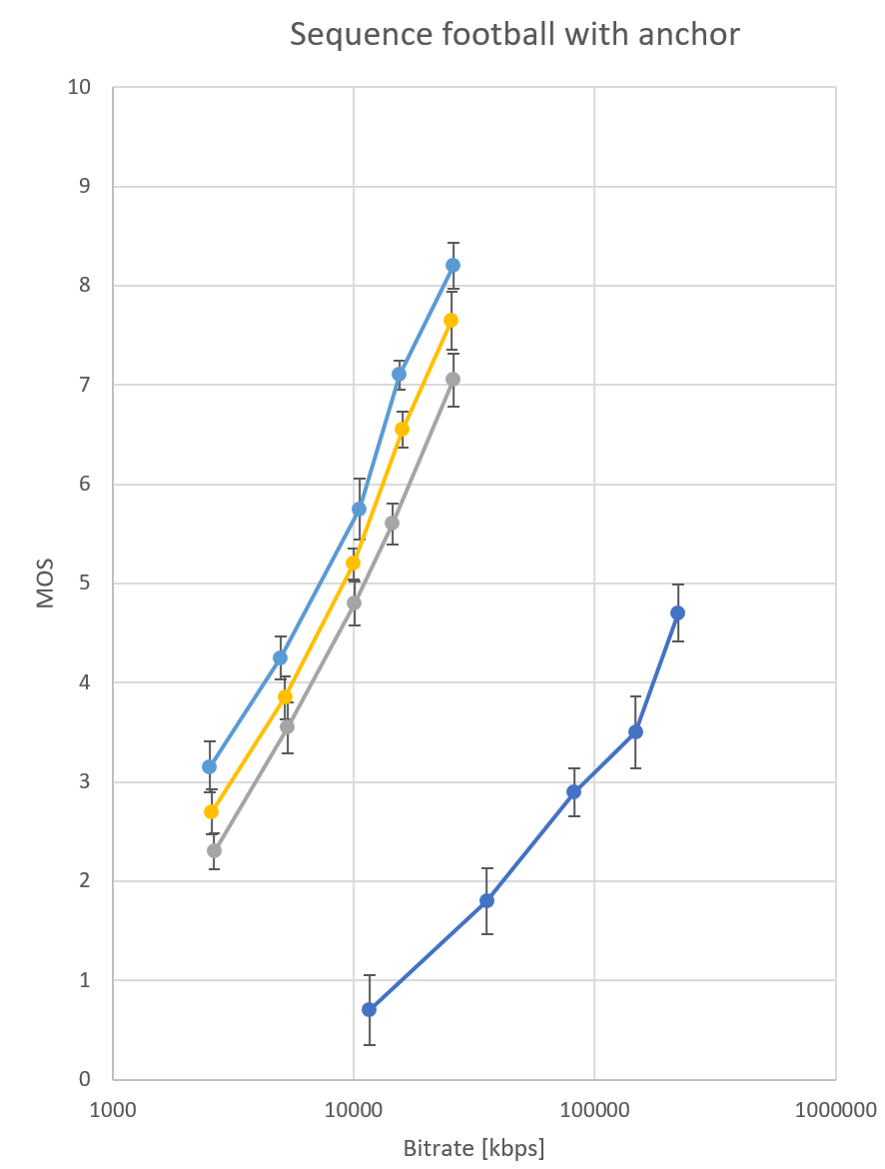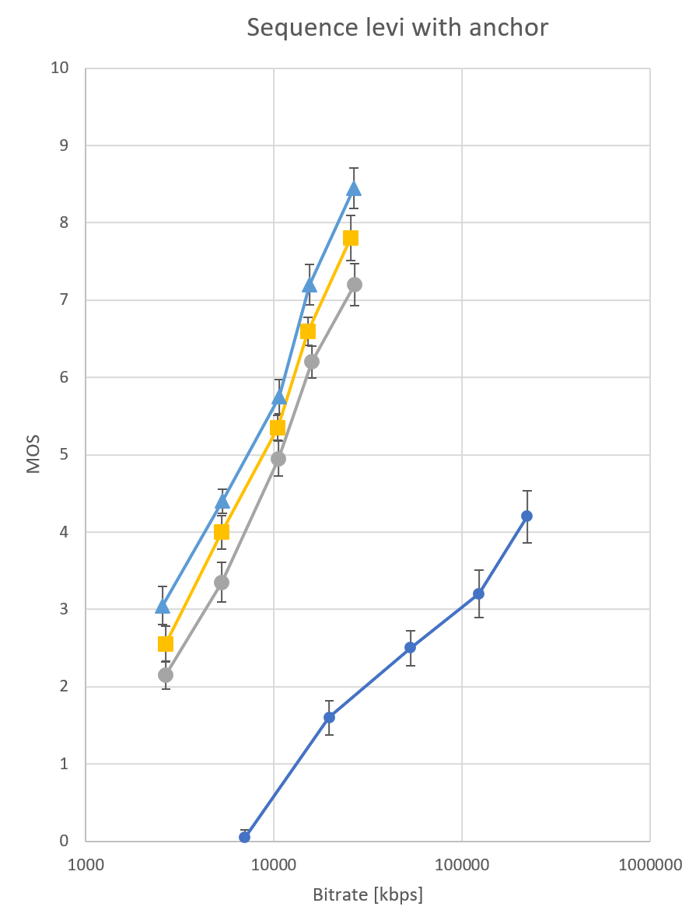
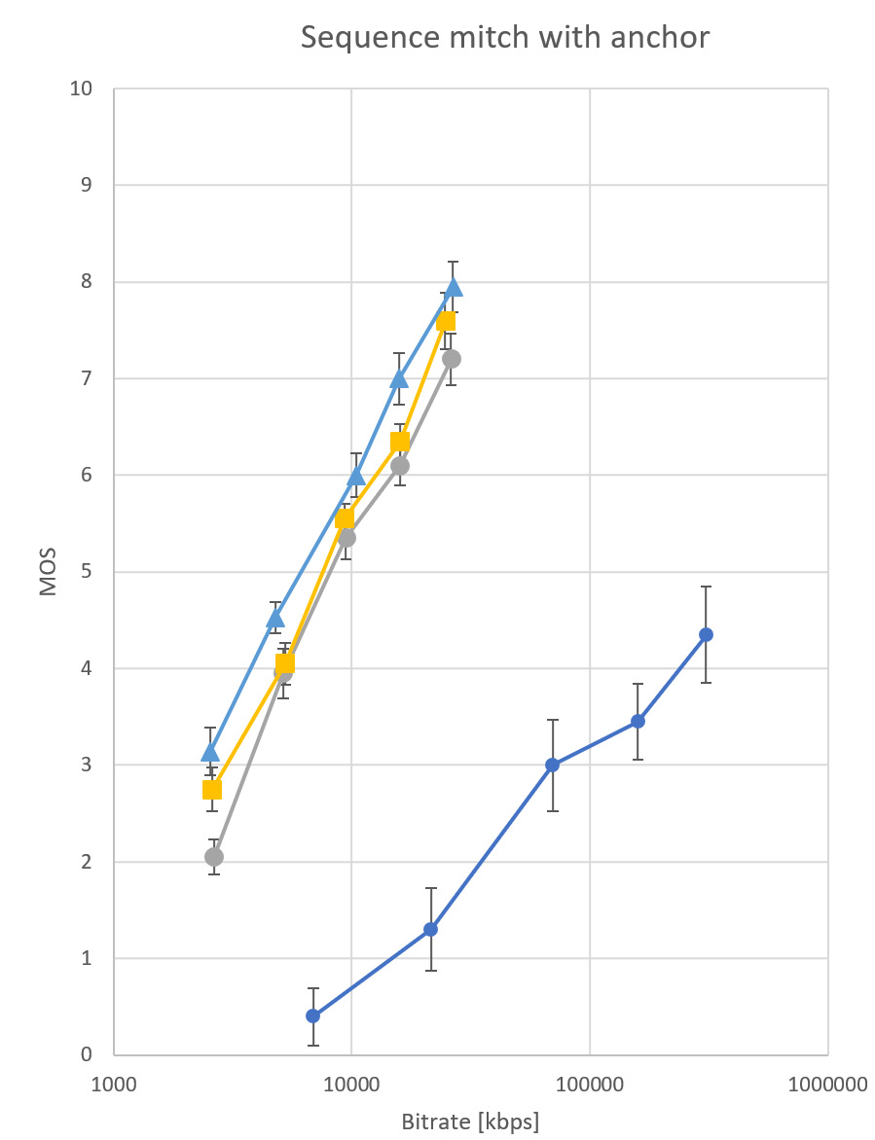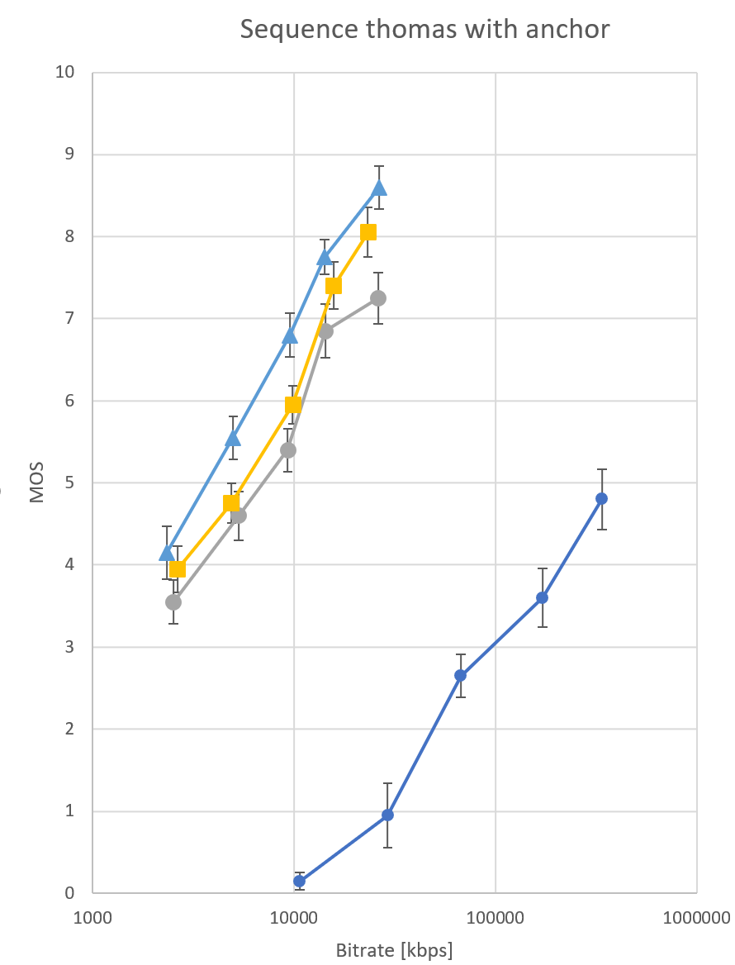
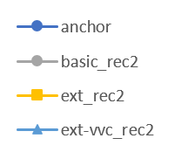
Figure 1 Graphs of V-PCC profiles against the anchor

Graphs of V-PCC profiles
In this section the graphs for of the selected V-PCC profiles are plotted for direct comparison of test results with a logarithmic scale for the bitrate on the x-axis.
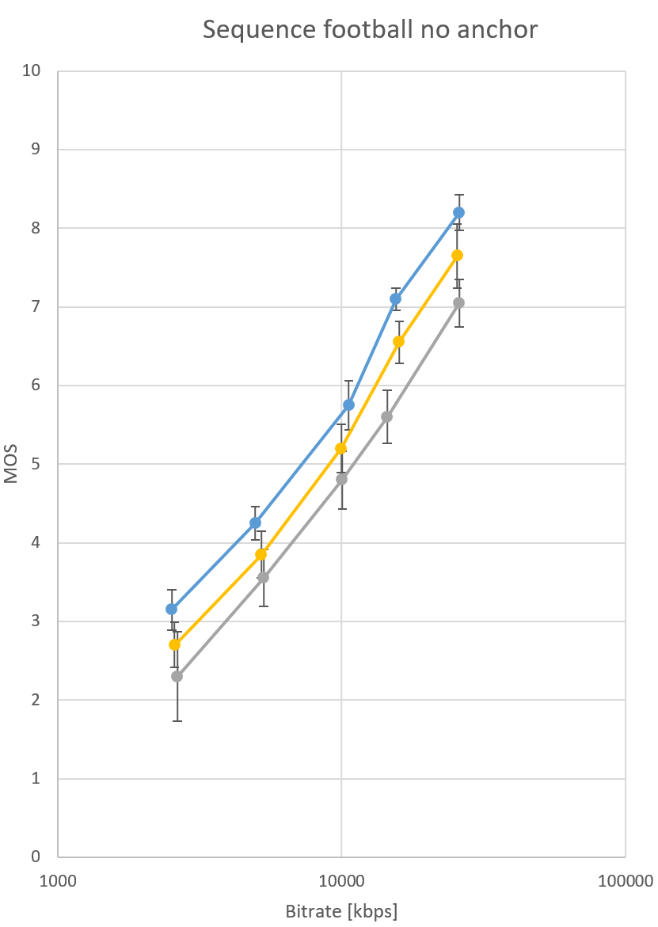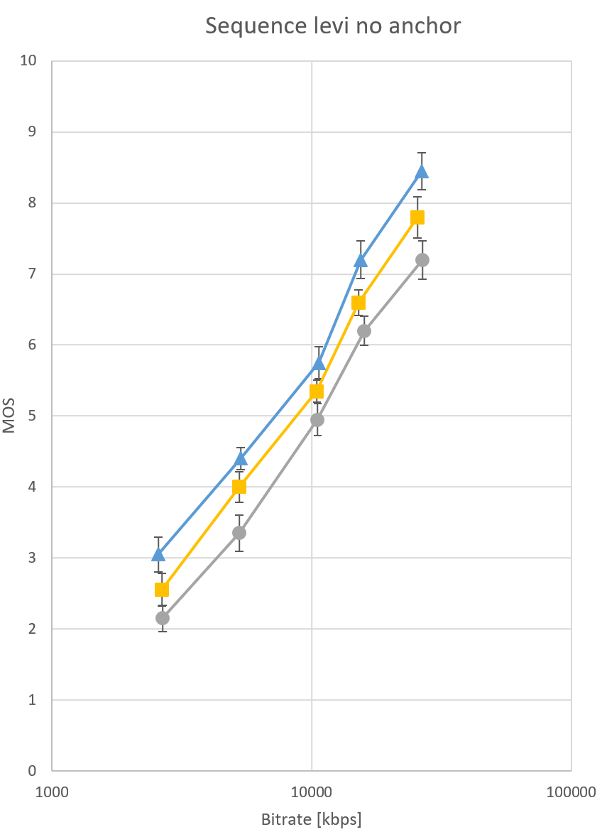
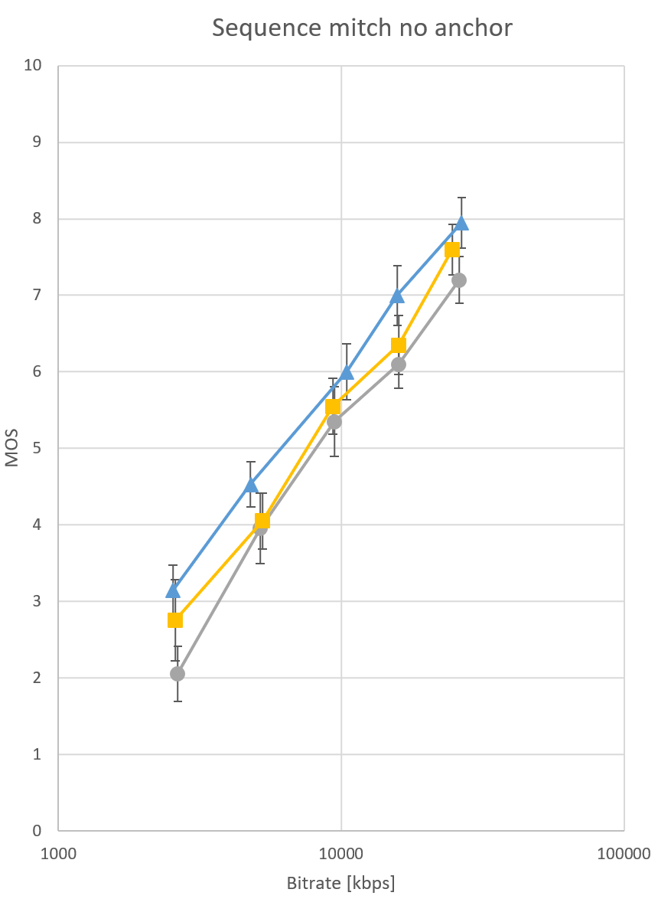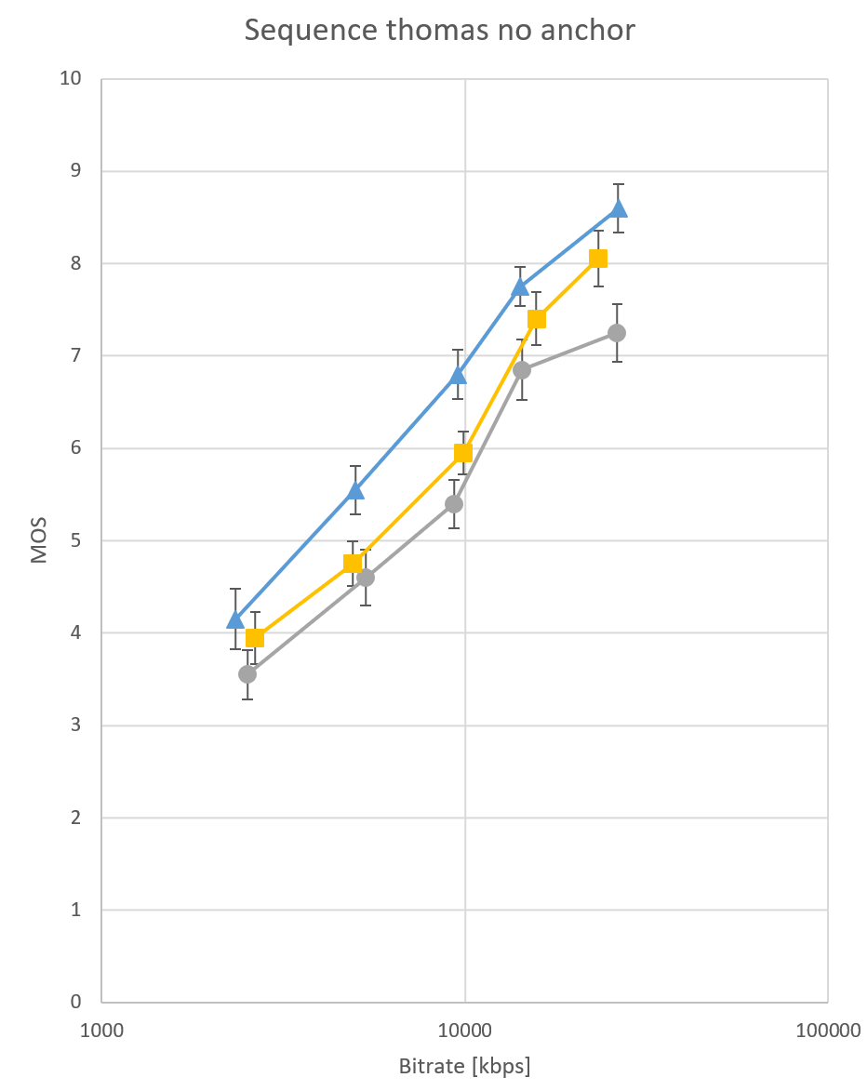
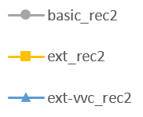
Figure 2 Graphs of V-PCC profiles

BD rate savings relative to HEVC Main10 Basic Rec2
Bjontegaard delta (BD) rate saving were computed based on the numbers reported in Section 7.1 using the method defined in [20].

Sequence | VVC Main10 Extended Rec2
football | -35.34
levi | -33.63
mitch | -29.29
thomas | -43.13
Average | -35.35
Table 10 BD rate savings
Note that gains are observed between the HEVC Main10 Basic Rec2 and HEVC Main10 Extended Rec2 profiles, however BD rates were not computed due to confidence interval overlap.

Expression of thanks
WG7 and AG 5 thank Apple, InterDigital, Sony, Samsung, RWTH, and Telecom SudParis for having carried the bulk of the work for preparing the V-PCC verification tests. WG7 and AG5 also thank Apple, InterDigital, Nokia, Sony, and Samsung for having contributed to the funding of the subjective tests carried out by the test labs. Furthermore, WG7 and AG5 thank Mathias Wien and Vittorio Baroncini for providing their advice during the preparation, Mathias for performing two dry-run tests and accepting to be the test coordinator, and Vittorio and Giacomo Baroncini for performing the Formal Subjective Assessment Experiments.

Conclusions
The herein presented subjective test results for some V-PCC profiles confirm the performance of the V-PCC coding specification and its reference encoder implementation and demonstrate that this standard can clearly outperform a previous state-of-the-art codec for point cloud compression [9]. The test also demonstrates how performance can be improved by just switching the underlying video coding specification from HEVC to VVC and using a similarly configured encoder. It is noted that there was no application specific or subjectively tuned optimization of the codec configurations, so it may be possible to obtain better coding performance for each of the profiles. Such optimizations are usually done for commercial products and go beyond the work of MPEG. The produced bitstreams for Rec2 could be reconstructed with different methodologies that may provide different quality-implementation trade-offs, but these trade-offs were not evaluated in this test.

References
- Recommendation ITU-R BT.500-14 (2019), Methodologies for the subjective assessment of the quality of television images
- Documentation for Point Cloud Renderer, ISO/IEC JTC1/SC29 WG11 Doc. m56757, Online, April 2021
- Call for Proposals for Point Cloud Compression V2, ISO/IEC JTC1/SC29 WG11 Doc. N16763, Hobart, AU, April 2017
- V-PCC Test Model v15, ISO/IEC JTC1/SC29 WG7 Doc. N00147, Online, July 2021
- Requirements for Point Cloud Compression, ISO/IEC JTC1/SC29 WG11 Doc. N17353, Gwangju, KOR, January 2018
- Common Test Conditions for V3C and V-PCC, ISO/IEC JTC 1/SC 29/WG 7 Doc. N0038, Online, October 2020
- Report on VVC compression performance verification testing in the SDR UHD Random Access Category, Joint Video Experts Team (JVET) of ITU-T SG 16 WP 3 and ISO/IEC JTC 1/SC 29 Doc. JVET-T0097
- SBTVD TV3.0, CfP Phase 2 / Testing and Evaluation: TV 3.0 Project, March 15th 2021
- Open Source Software Framework for Implementation and Evaluation of Point Cloud Compression, ISO/IEC JTC 1/SC 29/WG 11 Doc. m36527, Geneva, June 2016
- Point Cloud generation from Meshes, ISO/IEC JTC 1/SC 29/WG 7 Doc. m57590, Online, July 2021
- Report on remote experts viewing dry run for VPCC, ISO/IEC JTC 1/SC 29/WG 7 Doc. m57598, Online, July 2021
- Anchor codec description and profiles for verification test, ISO/IEC JTC 1/SC 29/WG 7 Doc. m58286, Online, October 2021
- Guidelines for Verification Testing of Visual Media Specifications (draft 2), ISO/IEC JTC 1/SC 29/AG 5 Doc. N00030, Online, July 2021
- V-PCC Verification Test Dry-Run Results, ISO/IEC JTC 1/SC 29/AG 5 Doc. m58026, Online, October 2021
- Report on remote experts viewing dry run for VPCC, ISO/IEC JTC 1/SC 29/AG 5 Doc. m57598, Online, July 2021
- A crosscheck of V-PCC verification test material corresponding to HEVC-basic-rec0 profile, ISO/IEC JTC 1/SC 29/WG 7 Doc. m58263, Online, October 2021
- Verification Test Cross-check, ISO/IEC JTC 1/SC 29/WG 7 Doc. m57991, Online, October 2021
- V-PCC verification test crosscheck, ISO/IEC JTC 1/SC 29/WG 7 Doc. m58259, Online, October 2021
- Information technology — Coded representation of immersive media — Part 5: Visual volumetric video-based coding (V3C) and video-based point cloud compression (V-PCC), ISO/IEC 23090-5:2021, June 2021
- International Telecommunications Union – Telecommunications Standardization Sector; “Working practices using objective metrics for evaluation of video coding efficiency experiments.” Technical Paper HSTP-VID-WPOM, July 2020. http://handle.itu.int/11.1002/pub/8160e8da-en
- Plan for V-PCC Verification Tests, ISO/IEC JTC 1/SC 29/WG 7 Doc. N00160, Online, July 2021
- V-PCC verification test create video, ISO/IEC JTC 1/SC 29/WG 7 Doc. m58291, Online, October 2021
- V-PCC Verification Test Report, ISO/IEC JTC 1/SC 29/AG5 Doc m58350, Online, October 2021
- Information technology — Coded representation of immersive media — Part 3: Versatile video coding, ISO/IEC 23090-3:2021, February 2021
- Information technology — High efficiency coding and media delivery in heterogeneous environments — Part 2: High efficiency video coding, ISO/IEC 23008-2:2013, December 2013

Annex A

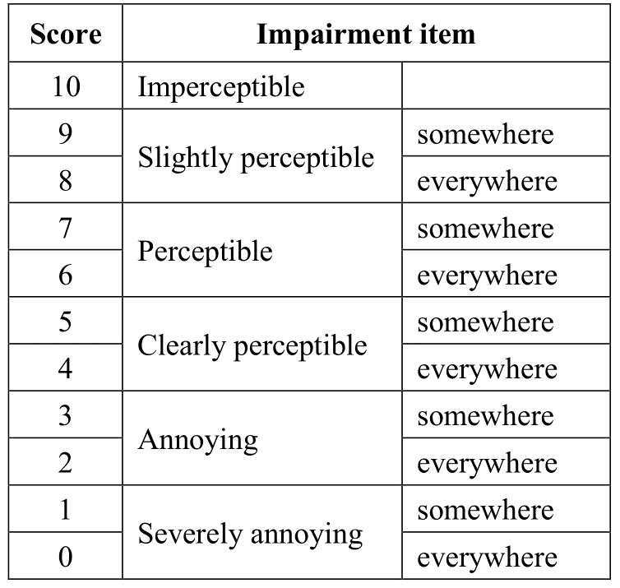
Table 11 Meaning of the 11 grades numerical scale as specified in ITU-R BT.500-14

